




Instruction manual
"WH 140"

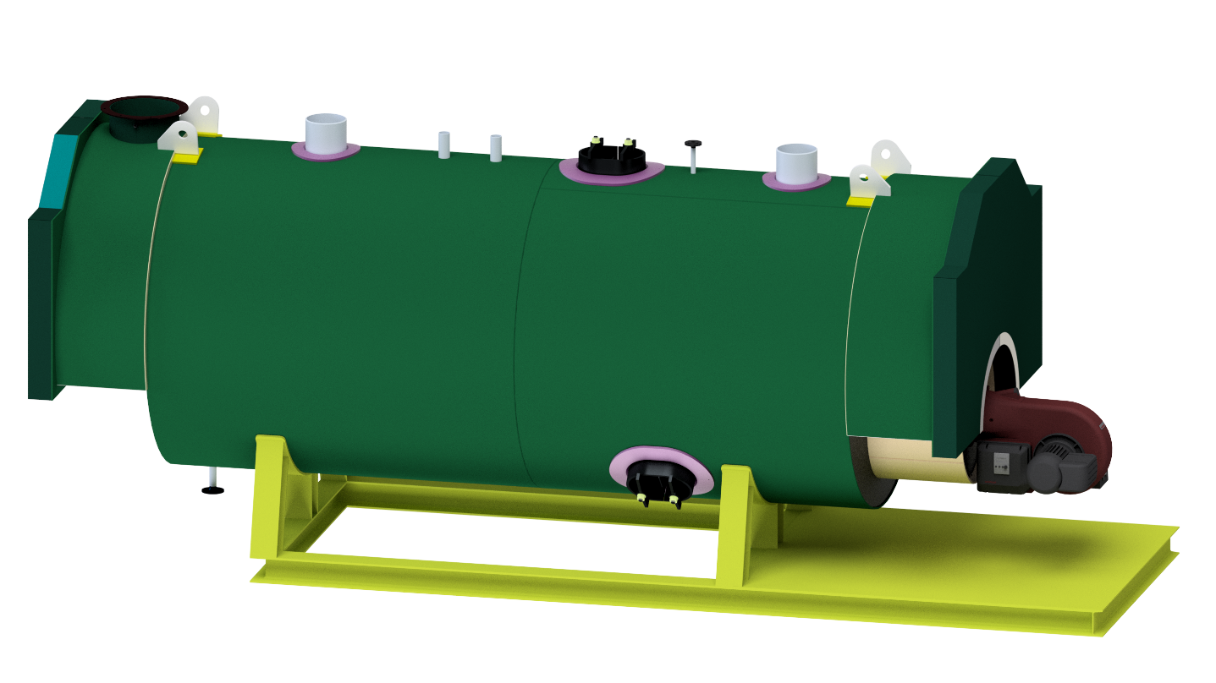

MANUFACTURER OF BOILERS AND EQUIPMENT FOR ENERGY PRODUCTION

PREAMBLE

Before installation and commissioning, please read this manual carefully, as it is designed to:

1. -SERVE AS A GUIDE FOR INSTALLATION WORK
2. -MAKE IT EASIER TO UNDERSTAND HOW IT WORKS
3. -HELP DETECT ANY MALFUNCTIONS AND SOLVE THEM

All suggestions given in this manual are subject to change or annulment by legislative prescriptions, and the construction company cannot in any case be held responsible for negligence, or problems resulting from the Client's failure to comply with the law.
It is therefore necessary to be aware of the laws, decrees and ordinances in force, or to consult the authorities that supervise what concerns superheated hot water installations and their auxiliaries such as: engines, gaseous emissions, chimneys and fuel storage.

INTRODUCTION

This guide gives, after describing the material supplied, the instructions for driving and maintaining the boiler.
In all matters relating to the equipment used by our suppliers, the particular information provided by them must also be taken into account.
The precise elements for the regulation will only be defined when they are put into service and will be given to the Operating Service at that time.
Obviously, during the start-up of the Boiler, the Private Start-Up Instructions will be drawn up, which will be provided to the Customer.

SAFETY FEATURES:
This equipment is equipped with a SIL safety system in order to increase the intrinsic safety of the equipment.

- 1 JUMO SIL3 safety temperature transmitter, does the safety function, turns the burner on and off.
- 1 KROHNE SIL3 pressure transmitter that performs the overpressure safety function in the boiler
- 2 Safety valves trip in the event of a failure of the temperature and pressure control systems.
- 1 SIL3 water safety level detector which does the safety function for water shortage.

BOILER CONTROL PANEL
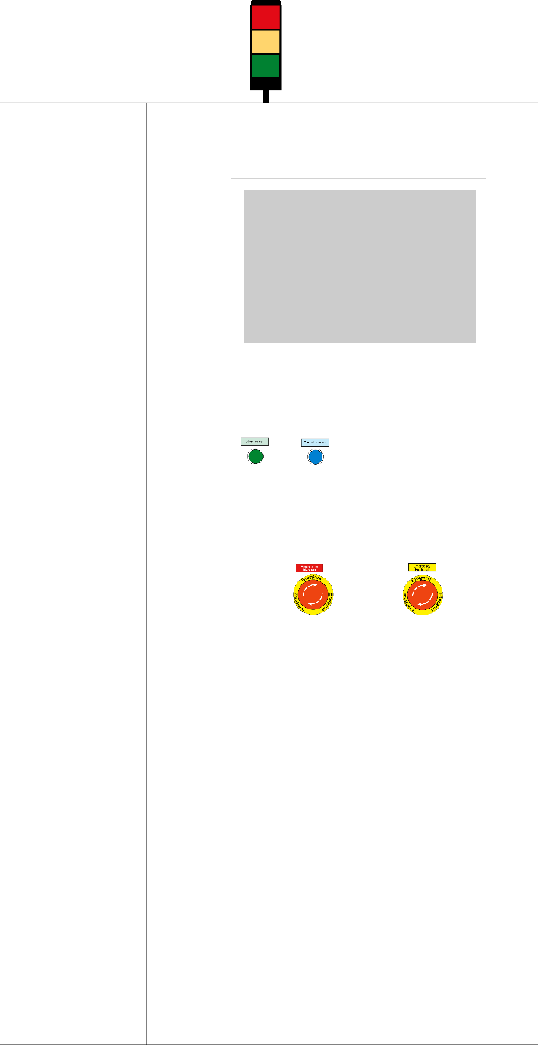
HMI for boiler’s visualization
Light indicator

Acknowledge and cancel alarm button

Biodiesel emergency stop

Automation cabinet

The control cabinet mounted in a metal cabinet comprises:
- PLC and HMI interface
- Automation relays, circuit breaker contactors with thermal protection for starting motors; short circuits as well as connection terminals for the arrival of current;
- Indicator plate with switches and buttons to control the different elements;
- Boiler safety level relays
- Variable frequency drives and soft motor starter
- All automation and safety equipment is provided for alternating current, 3F + N + T, 230V, 50 Hz.

SAFETY SIMBOLS / WARNINGS

The safety symbology presented below, located on the boiler, provides indications, information and instructions that must be followed by the operator.

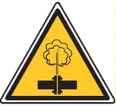 | 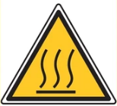 | 
CAUTION HIGH PRESSURE | CAUTION HIGH TEMPERATURE | CAUTION MOVING PARTS

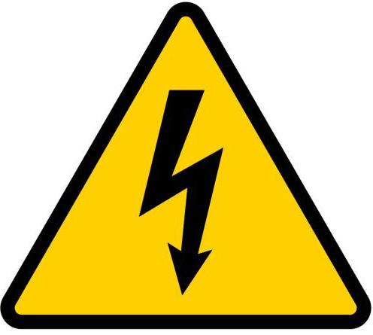 |  | 
CAUTION ELECTRICAL HAZARD | CAUTION OTHER  DANGERS | CAUTION CARBON MONOXIDE MAY BE PRESENT

 | 
READ INSTRUCTION MANUAL | EMERGENCY STOP BUTTON

The various pictograms, as well as the type plate, must be kept in good condition, and must never be removed or moved from the places where they are placed..

ATTENTION!

In the event of an emergency, where the boiler must be completely shut down (except circulation pumps), press the emergency control panel (figure a).

EMERGENCY BIODIESEL BOILER

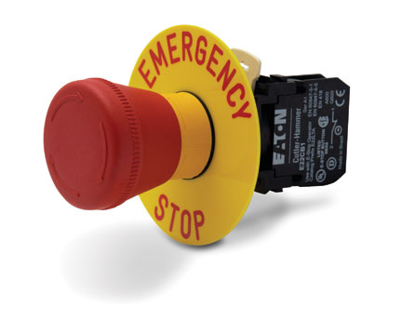
Figura a

ATTENTION!

These systems should not be altered, as they contribute to the intrinsic safety of the machine.

Description of Main Components

8
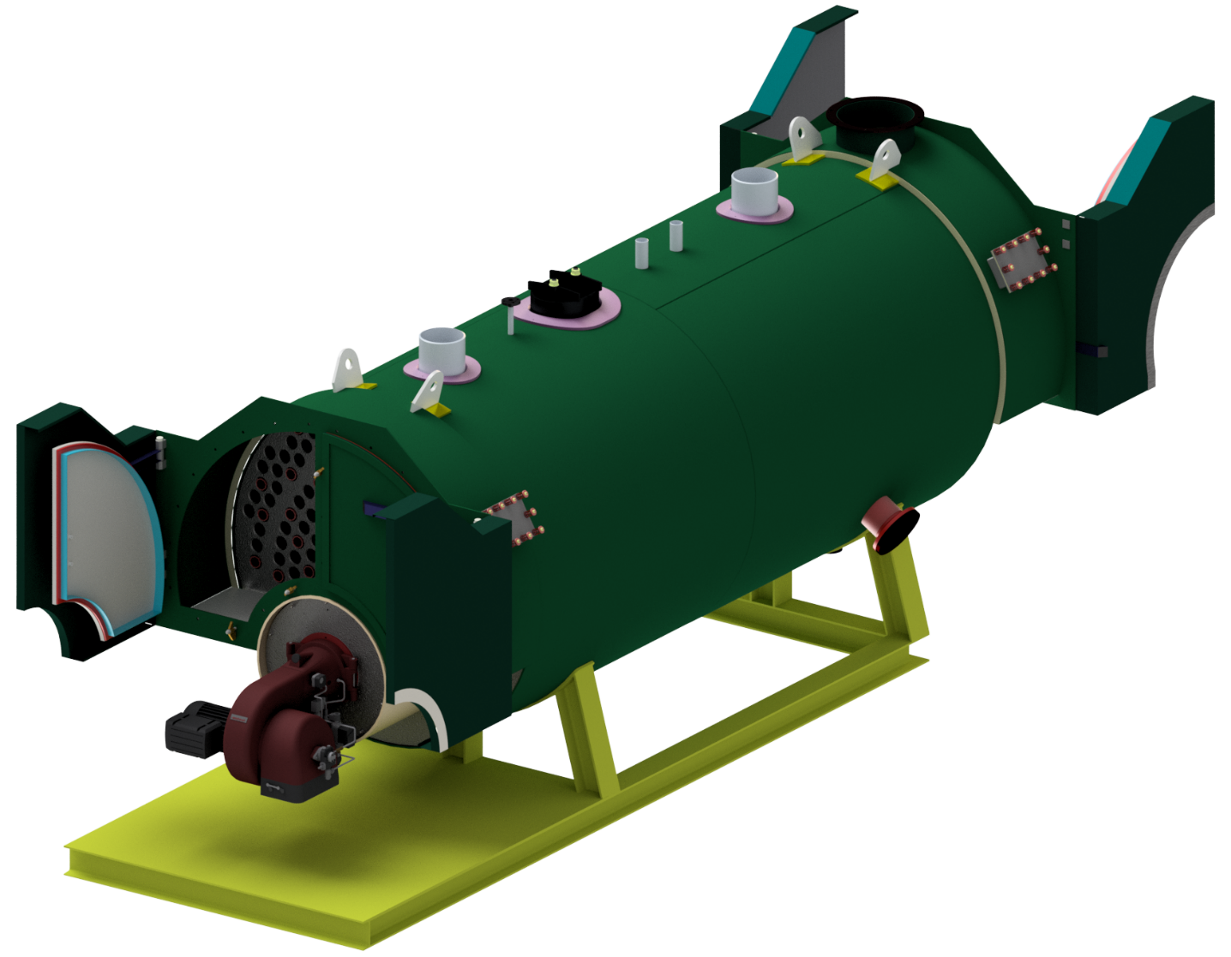
9
10
13
12
11
7
5
6
4
3
2
1
1
Boiler Front

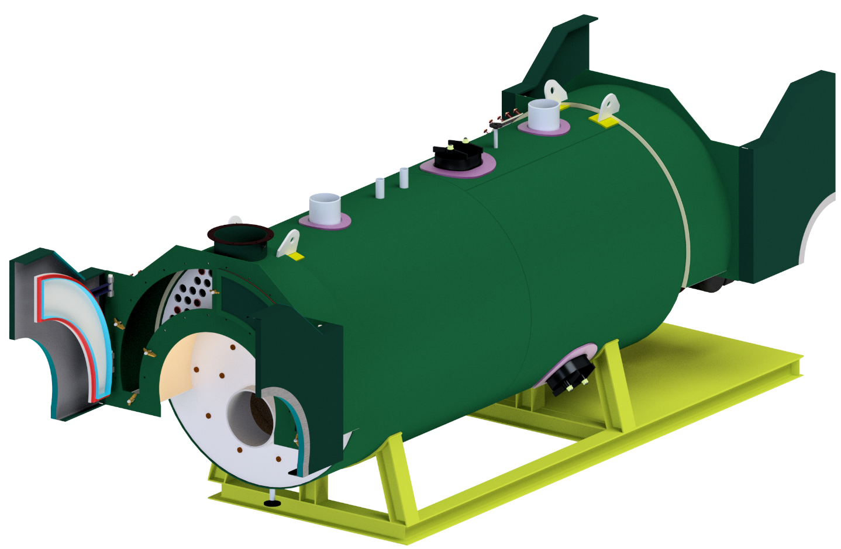
22
21
20
19
18
17
16
15
14
Boiler Back

Nº | 1 + 8
Item | Insulation door
Function | Thermal insulation of the interior soot door
Hazards

Nº | 2 + 16
Item | Soot door
Function | Access door to the flue gas circuit
Hazards | 

Nº | 3 + 14
Item | Loading lugs
Function | Used to load / move the boiler (empty of water)
Hazards

Nº | 4 + 7
Item | Water inlet / outlet pipe
Function | Water inlet / outlet when boiler is running
Hazards

Nº | 5
Item | Deaeration valve
Function | Used to remove air from the boiler
Hazards

Nº | 6 + 18
Item | Inspection Door
Function | Used to inspect the interior of the boiler, only when empty of water
Hazards

Nº | 9
Item | Combustion Overpressure door 2nd pass
Function | Pressure release mechanism in case of combustion overpressure on the flue gas 2nd pass
Hazards

Nº | 10
Item | Inspection Flange
Function | Used to inspect the interior of the boiler, only when empty of water
Hazards

Nº | 11
Item | Combustion Overpressure door 3rd pass
Function | Pressure release mechanism in case of combustion overpressure on the flue gas 3rd pass
Hazards

Nº | 12
Item | Burner
Function | Heat generation element burning biodiesel
Hazards

Nº | 13
Item | Bronze brackets
Function | Used to lock and keep gas tightness on soot doors
Hazards

Nº | 15
Item | Safety valves
Function | Safety pressure release valves – the output of these valves cannot have restrictions
Hazards

Nº | 16
Item | Stack
Function | Flue gas outlet, must be connected to a chimney dimensioned according to national legislation
Hazards

Nº | 19
Item | Boiler’s support
Function | Support of the boiler to the ground
Hazards | --

Nº | 20
Item | Drain valve
Function | Valve used to drain the boiler. – Make sure there is no leaks, and is tightly closed
Hazards

Nº | 21
Item | Combustion Overpressure door 1st pass
Function | Pressure release mechanism in case of combustion overpressure on the flue gas 1st pass, is used to access the combustion chamber and to inspect the flame when the burner is running
Hazards

Description of materials and project thicknesses

In this section are described the design materials and minimum thicknesses required to ensure the integrity of the pressure body.

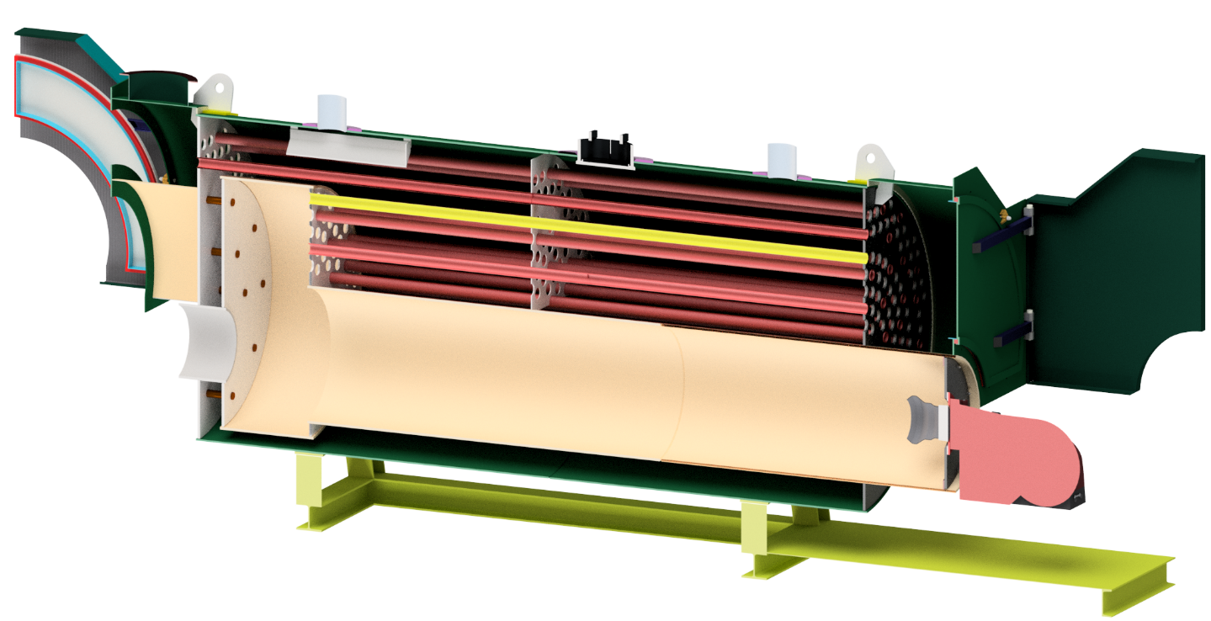
G
H
I
J
L
K
D
E
F
C
A
B

Pressure part

ID | Description | Material | Minimum thickness
A | Front Plate | P265GH | 18 mm
B | Exterior Shell | P265GH | 10 mm
C | Interior Shell furnace | P265GH | 16 mm
D | Interior front Plate | P265GH | 18 mm
E | Reversing chamber shell | P265GH | 16 mm
F | Interior back plate | P265GH | 18 mm
G | Back Plate | P265GH | 18 mm
H | Interior access Shell | P265GH | 12 mm
I | Exterior Pipes | P265GH | 2 mm
J | Inspection door Plate | P265GH | 12 mm
K | Smoke Tubes normal | P235GH | 2 mm
L | Smoke Tubes reinforced | P235GH | 6,3 mm (x 20 tubes min)

Description of the operation MODE.

Operative Sequence

Before starting the boiler, the following should be taken into account:
1 - Make sure there is an electric current.
2 - Make sure there is water in the deaerator and in the supply network.
3 - Check that it is safe to start the boiler

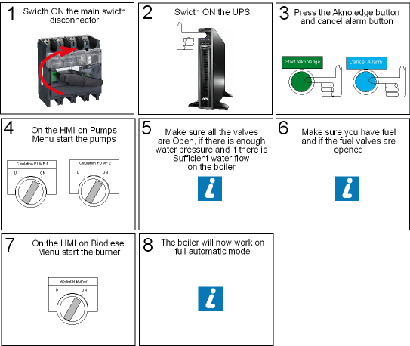

Stop the boiler

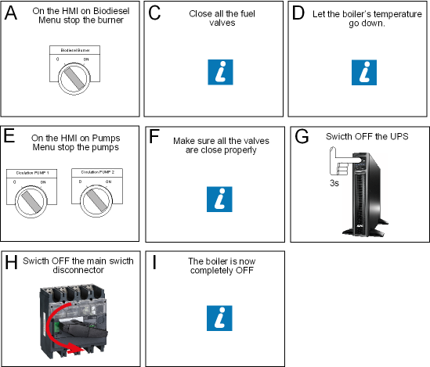

Machine Operation Recommendations

In case of breakdown or error, follow the instructions visible on the boiler console, in case of doubt always consult this instruction manual, or contact Flucal caldeiras S.A..

If during normal boiler operation you notice that the touch console has turned off, and you want to see something, touch the console screen until it turns back on. This happens in order to increase the useful life of this equipment.

ATTENTION!

All safety devices must be checked/fitted before starting to operate the Boiler.
You should work in dry environments and keep electrical connections clean and well-adjusted.

ATTENTION!

Operations to Be Performed in the Event of a Local Incident

Lack of Water
The lack of water can be caused by a leak, steam formation in some element or failure in the pressurization system.

Lack of Fuel
To look for the cause of this extinction to ensure permanent surveillance of the boiler until the repair has been carried out.

ATTENTION!
Before reintroducing fuel into the boiler, make sure it is safe to do so.

Boiler Tube Rupture
It is recognized that a boiler empty of water, especially under steam pressure, as is the immediate case after a pipe rupture, is subject to serious stress due to temperature differences.
In the event of a pipe breakage, proceed as follows:
- Turn off fuel burn
- Cut off the fuel supply.
- Allow the boiler temperature to drop until the pumps can be switched off
- Turn off the circulation pumps
- Close the boiler inlet and outlet valves
- Open the boiler drain valve until it is completely empty

ATTENTION!
Always check that it is safe to carry out an intervention on the boiler

Manutenção Geral

Maintenance Table
Compliance with the actions defined in the preventive maintenance plan significantly increases the reliability, economy and safety of the boiler.
Maintenance operations must be carried out periodically and are reflected in the following table. For each maintenance intervention, the frequency, type of intervention and the qualification of the personnel necessary for its execution are mentioned.

Frequency | Type | Description of the Action/Part to Be Verified | Qualification
Weekly** | ■ | Moving parts of the burner, bushings and spherical plain bearings of the air-fuel mixing mechanism. | OM
Weekly | ○ | Exterior of the machine and the surroundings. | OM
Weekly | □ | Operation of visual and audible signals | OM
Weekly | □ ■ | Bearings, bearings, valves, motors, etc. | OM/OQM
Monthly | □ | Operation of the emergency panel, pressure switches and safety levels as well as the various sensors. | OM
Monthly | □ | Mechanical connections of the Pumps, and burner | OM
Biannual | □ | Retightening of the various mechanical connections | OQM
Biannual | □ | Operation of all boiler equipment. | OM/OQM
Biannual | □ | Electrical cables and pipes are broken. | WHAT
Annual | □ | Status of contacts, fuses, electrical connections and all electrical components of the boiler. | WHAT
Annual | □ | Testing Safety Valves | OQM

Caption:
□ – Control/Verify | OQM – Mechanically Qualified Operator
○ – Clean | OQE – Electro technical Qualification Operator
■ – Lubricate | OM – Machine Operator

Persons involved in maintenance and repair operations must understand the potential risks to which they are subject, so before starting work, they should carefully read the instructions set out in the owner's manual

ATTENTION!

When initiating any maintenance/repair intervention on the equipment, check:

- If the equipment is turned off.

- If all employees are aware of the intervention that is being carried out;

- That there is sufficient space around the equipment for the movements necessary for the intervention.

- If there are conditions of temperature, pressure and presence of gases to carry out maintenance

After each operation that requires the dismantling of fixed or mobile guards and safety devices, it is imperative not to start work without all the safety systems being in place.

LOTO – lock Out Tag Out
In order to be safe to carry out maintenance / interventions on the boiler, use the lock out tag out system on the main switch of the boiler, to do so proceed as follows:

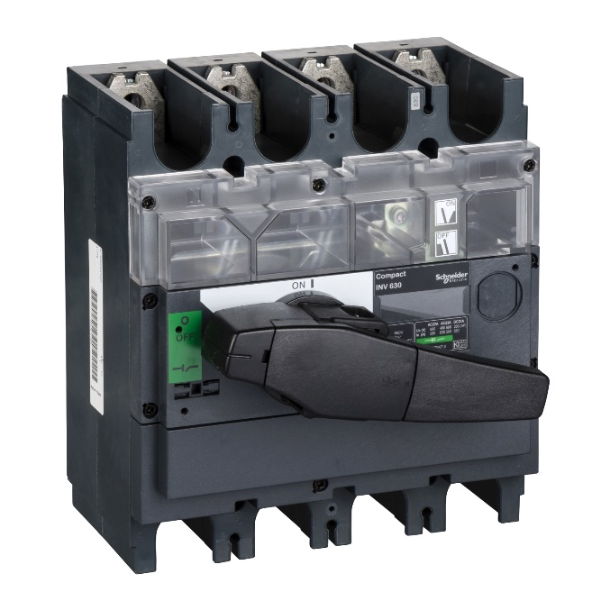  1st Pull black block | 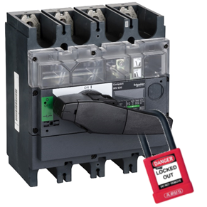  2nd Place the lock in the hole

Please remind to put warning label.
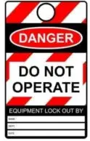
LOTO TAG

Description of replacement materials

The following list represents the replacement materials that may be required during maintenance / repair.

Description | To use on Item Nº | Characteristics
Smoke tube 2nd pass | Boiler | Ø76,1x3,6x3950
Smoke tube 3rd pass | Boiler | Ø76,1x3,6x4740
Fiber glass square rope | Soot door 2 + 16 | Square 28x28
Refractory concrete | Soot door 2 + 16 | 1400ºC refractory concrete
PTFE sealant | Inspection door 6 + 18 | Tape of expanded multidirectional PTFE with graphite 30x10mm
DN65 Gasket | 15 | Spiral wound gasket  DN65
DN200 Gasket | 10 | Spiral wound gasket  DN200
DN25 Gasket | 5 | Spiral wound gasket  DN25
DN40 Gasket | 20 | Spiral wound gasket  DN40
Sight glass | 21 | 2 x Fire resistant glass Ø55
PT100 flue gas | 16 | PT100 Ø6x250 0-500ºC 4-20mA

Maintenance Procedures

Tube cleaning procedure

Hazards


Please wear glasses, gloves and mask

1 – Open the insulation doors:
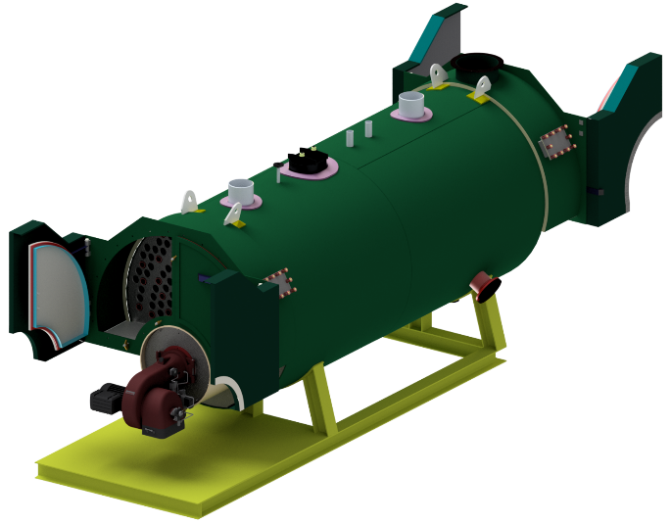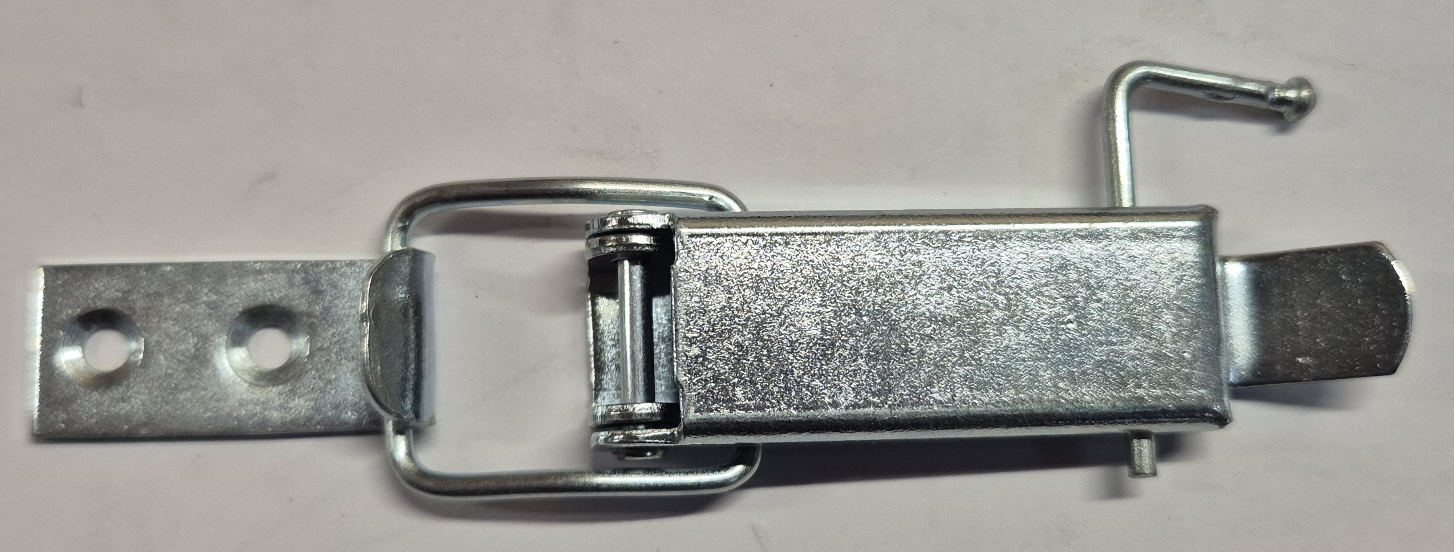

1.1 -Locate and Open the lock mechanisms

1.2 – remove pin | 1.3 – Open the lock | 1.4 - release the lock
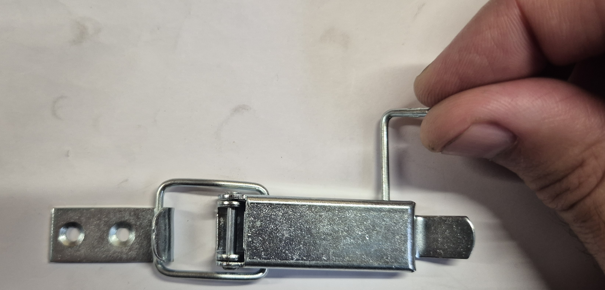 | 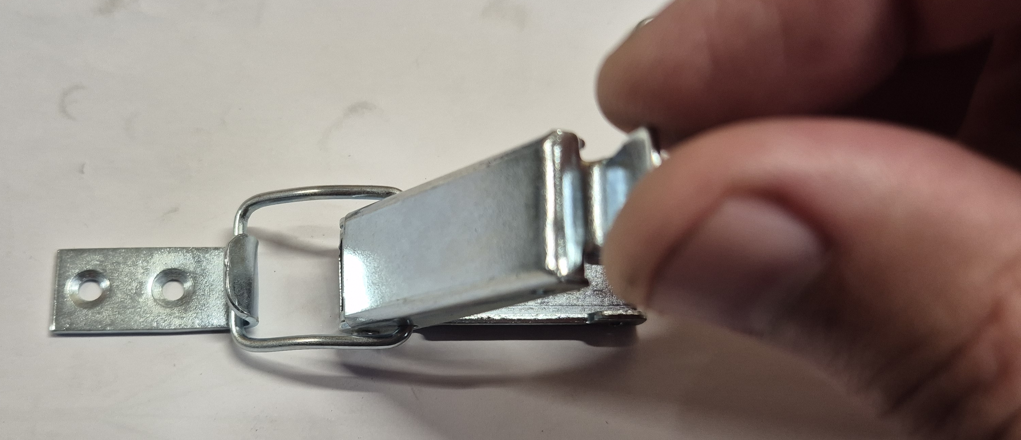 | 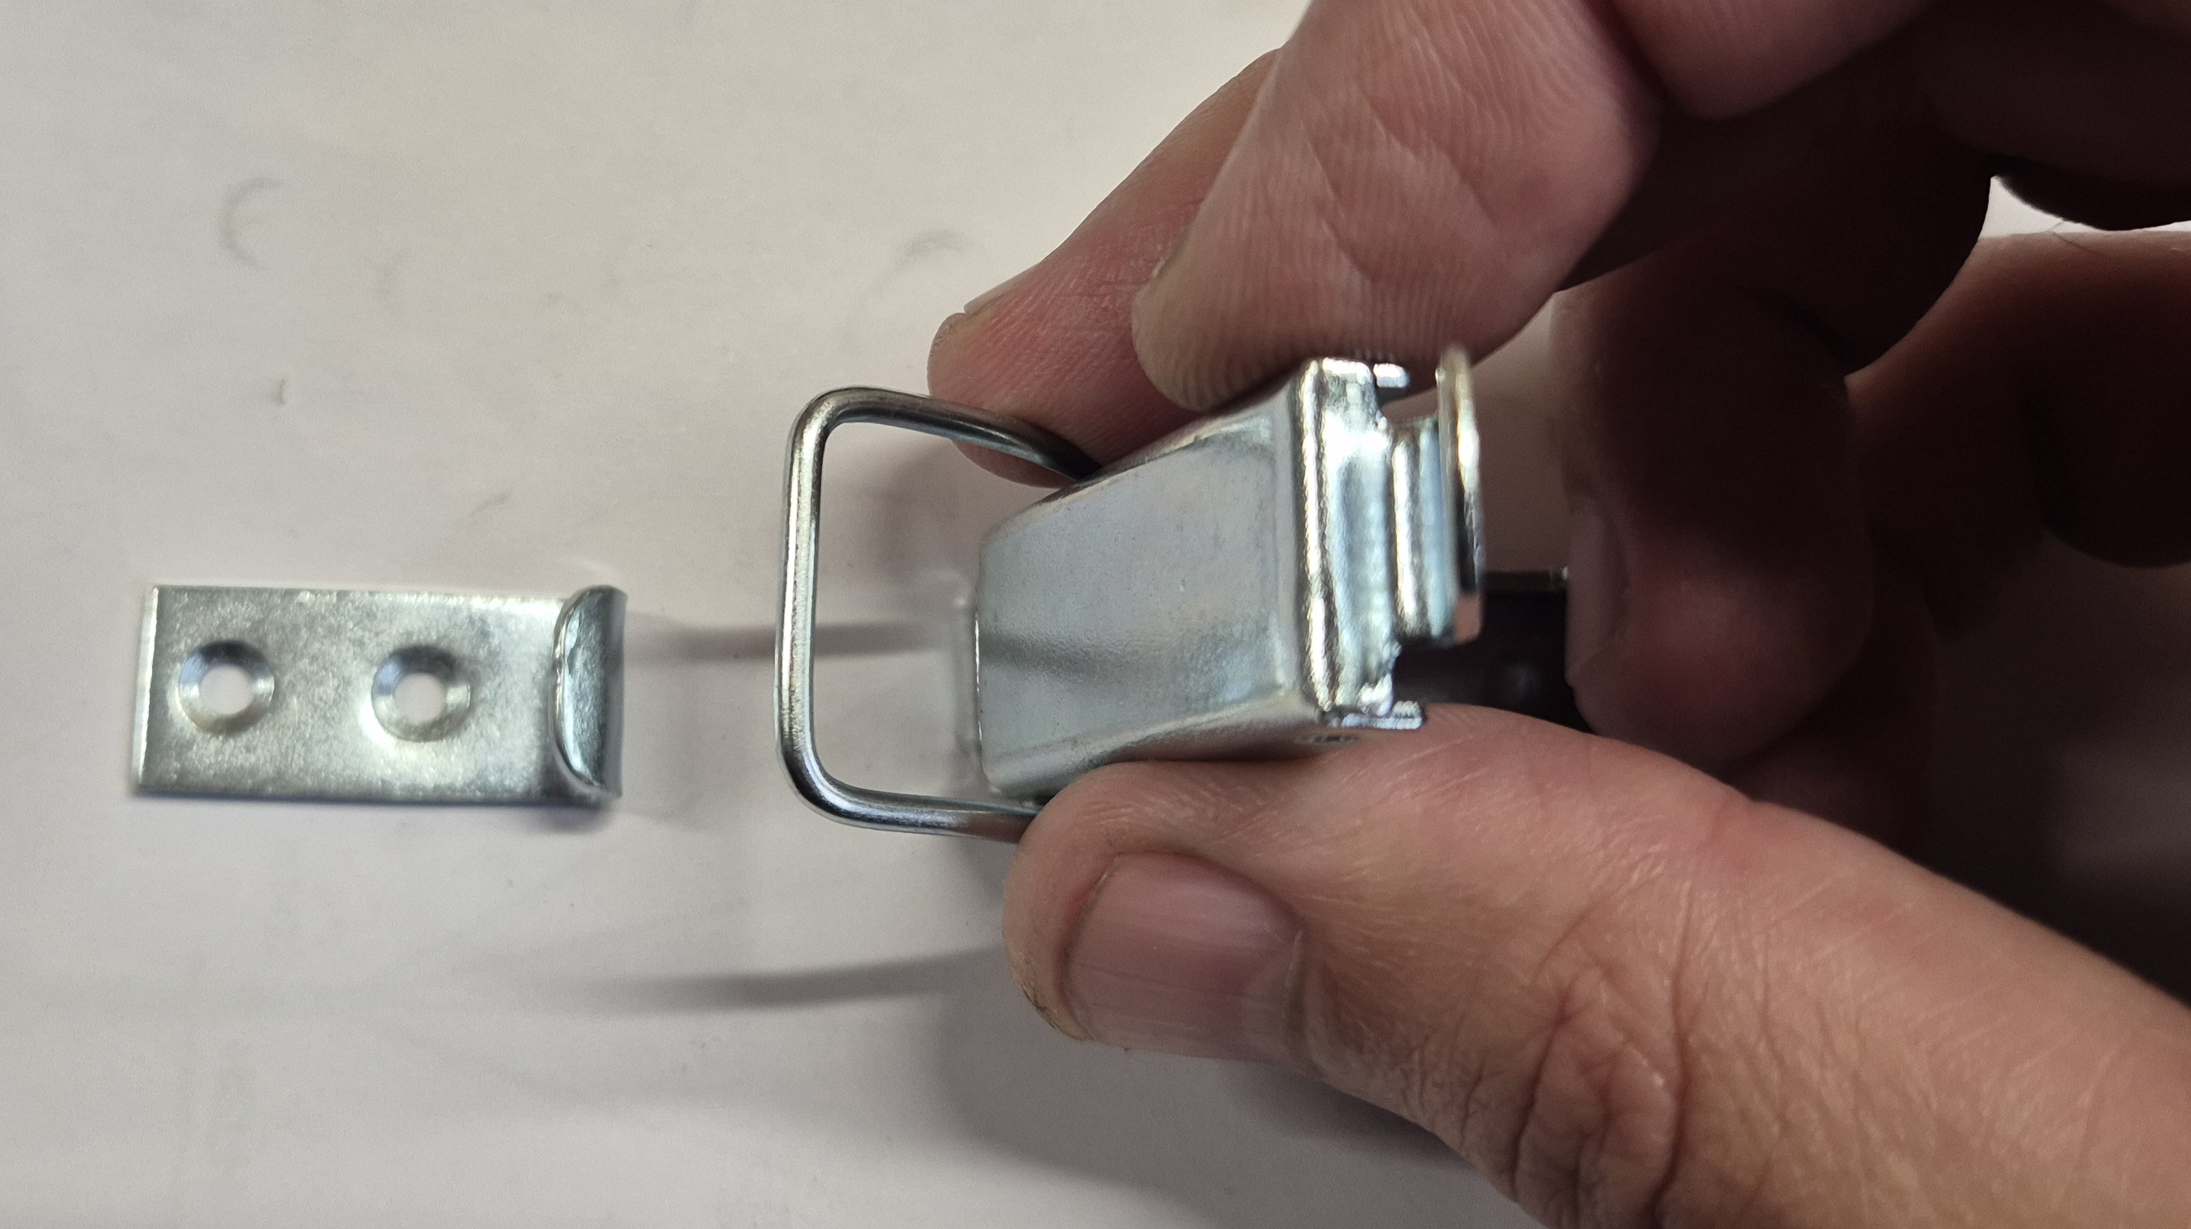

2 – Locate and unscrew all the 27 M16 Nuts that are closing the soot doors

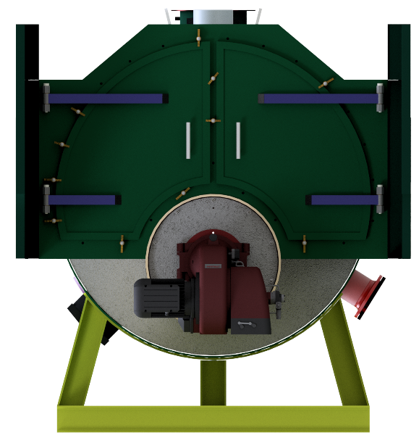

3 – Rotate all the 27 bronze locks in order to let the soot doors open

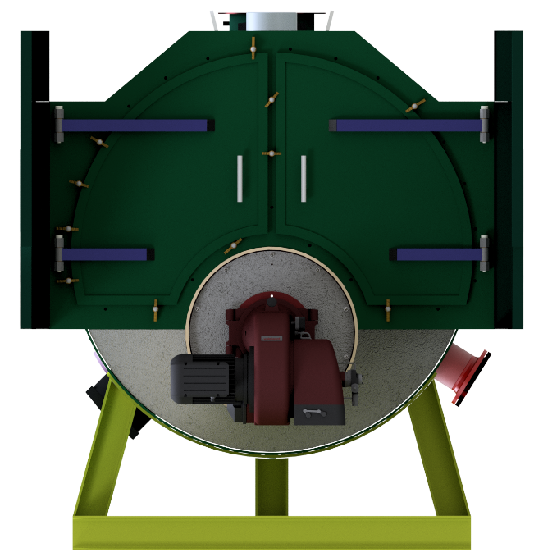

4 – Use cleaning equipment with Ø67 and Ø62 brush

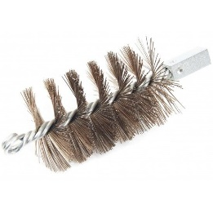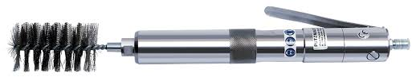

5 – Close all items in reverse order from from 3 to 1

Boiler’s interior access

Hazards

Please wear glasses, gloves and mask

1 - Locate the doors

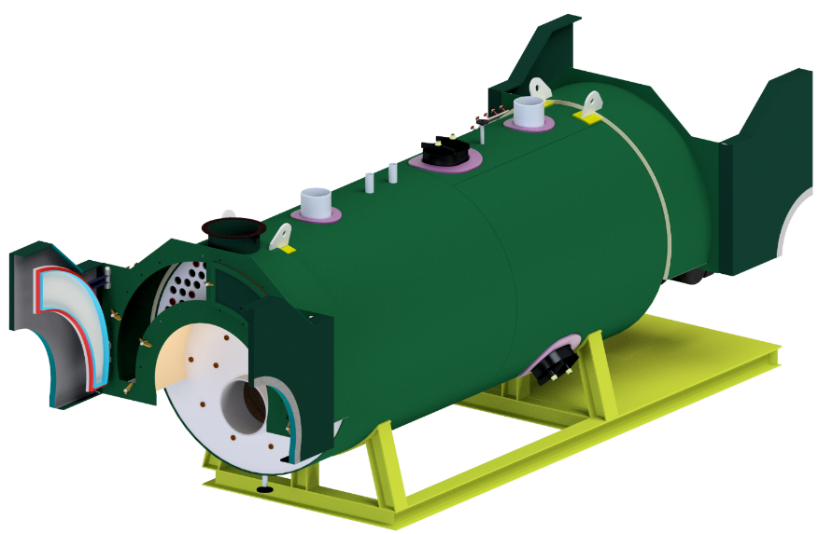

2 – Unscrew the M30 nuts and remove the brackets.

3 – Hold the door and push it in.

4 – Rotate the door in order to pull it out.

5 – In order to insert the door again replace the sealant with a new one -Tape of expanded multidirectional PTFE with graphite 30x10mm-

6 – To insert the door again repeat the steps in reverse order from 4 to 2.

Burner Maintenance

Hazards

Please wear glasses and gloves

Please refer to the burner’s instruction manual

Safety valves Maintenance

Hazards

Please wear glasses and gloves

The safety valves should be tested regularly depending on the fluid and local legislation.
To do that please use a pressure pump to increase the pressure in the system and to regulate/calibrate the valve.

Water Quality
Please refer to EN 12953-10 (hot water boilers)

Pressure Parts
A boiler must stop periodically for an inspection of the parts under pressure.

Inspection of the Inside of Pressure Parts
Before entering the pressure parts of a boiler, it is necessary to make sure that no hot water escapes from the valves connected to the organs of other boilers in service
In the course of the inspection, debris deposits and any corrosion attributable to water quality shall be detected and examined.
Any deposit must be taken before the boiler is re-put into service. If this deposit is thick, use a chemical cleaning treatment. Improve, if necessary, the quality of the boiler water.
Also check the condition of all organs and appliances so that they can function properly.

Inspection of the Exterior of Pressure Parts
Examine the outer surface of the pipes and the gaps between pipes to discover abnormal dirt or soot deposits. This examination should serve to fix the frequency of cleaning.
Also check the good condition of the refractory parts.

Electrical System

-Only qualified technicians or their assistants under their supervision and control, respecting the electro technical regulations, are authorized by Flucal, to carry out electrical maintenance/repair work;

-When maintenance and repair operations are carried out, the machine and complementary equipment must be disconnected from the mains, braked and properly identified to prevent its inadvertent operation and accidents;

-If you want to carry out maintenance after switching off the main switch, insert a suitable lock for this purpose on the main switch in position 0 Off.

-If an electrical fault is detected, such as damaged cables or components, the machine must be switched off.

Spare Parts

-Whenever there are worn or damaged parts, contact FLUCAL, SA.

Waste Disposal and Dismantling

Scrap Disposal

-The collection and disposal of special waste – toxic-harmful, such as used oils, etc., must be handed over to companies licensed for this purpose.

- Mobile containers intended to contain toxic or harmful waste must have adequate resistance requirements in relation to the chemical-physical properties of waste.

Dismantling Process

-Considering that different legal provisions are in force in the various countries, the imposed specifications must be fully followed.

-Empty the lubrication storage tanks and mechanical work.

-Disassemble the parts of the machine by grouping the components according to their chemical nature.

-Proceed with the distribution of the various types of scrap in accordance with the legislation in force in the customer's country.

ATTENTION!

Dismantling operations must be carried out by specialized Flucal personnel.

FLUCAL Copyright 2024

